Dataset 3: Notifications & Sustained Attention

Scenario Overview
Students used a study app that recorded how long they stayed on task before mind-wandering. They also reported the number of phone notifications they received per hour during study. A scatterplot displays notifications per hour against time on task (seconds).

Data Summary
Notifications per hour | Time on task before mind wandering (s)
1 | 210
2 | 195
3 | 205
4 | 180
5 | 190
6 | 175
7 | 165
8 | 155
9 | 175
10 | 180
4 | 220
7 | 150

Figure
Figure 1. Notifications per hour versus time on task. Pearson’s correlation (r) = -0.76.
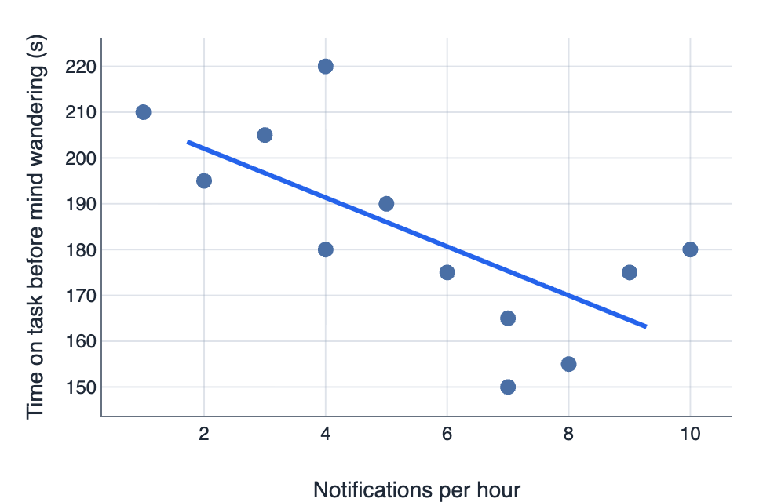

IA1 Practice Questions
- Using the line of best fit shown in Figure 1, estimate the predicted time on task for a student who receives 6 notifications per hour.

- Determine the strength and direction of the correlation using the r-value provided (r = -0.76).

- Identify the overall trend and one possible outlier.

- Identify the general relationship between the two variables shown in the scatterplot.

- Justify why a causal conclusion cannot be made from these data.

- Predict the change in time on task if notifications halve from 8 per hour to 4 per hour.

